CSCD330 – Computer Networks

Final Exam, Winter 2021

Due: 18 MAR 2021, 11:59am PDT

Ian Kaiserman

Instructions: Write your answers to the following questions. A good idea would be to copy-andpaste these questions to your document followed by your answer (not needed for binary blocks in question 4). Add citations for anything you find not in the textbook or lecture notes. Also, include your name on your answer sheet **(6 points)**.

BE AWARE: NO LATE SUBMISSIONS WILL BE GRADED.

**Question 1. (9 points)**

Some IP Arithmetic

1. IPv6 uses 16-byte addresses. If a block of 1 million addresses is allocated every picosecond, how long will the addresses last?
   1. 2^(16bytes*8bits)addresses * 1picosecond/1000000addresses * 1second/1000000000000picoseconds * 1minute/60seconds * 1hour/60minutes * 1day/24hours * 1year/365days = **3.40 * 10^38 years**
2. Convert the IP address whose hexadecimal representation is C22F1582 to dotted decimal notation.
   1. C2 = 2 + 16*12 = 194
   2. 2F = 15 + 16*2 = 47
   3. 15 = 5 + 16*1 = 21
   4. 82 = 2 + 16*8 = 130
   5. **194.47.21.130**
3. Suppose that instead of using 16 bits for the network part of a class B address originally, 20 bits had been used. How many class B networks would there have been?
   1. Original class B: 2^(16) – 1 = 65535
   2. New class B: 2^(20) – 1 = **1048576**

# Question 2. (10 points)

What conditions will cause a datagram to be fragmented? When a large datagram is fragmented into multiple smaller datagrams, where does this fragmentation occur? Where are these smaller datagrams reassembled into a single larger datagram?

**Fragmentation happens when a payload size exceeds the maximum packet size of the link it is being sent through. Fragmentation was created to accommodate different network technologies. Fragmentation occurs at routers. Hosts reassemble the fragments into the whole original datagram.**

**Question 3. (10 points)**

A DHCP client sends out broadcast messages in two occasions before it hops on the Internet. What are these two and why are they broadcast?

**The two broadcast messages are DHCPDiscovery and DHCPRequest. These are broadcast because it allows for the client to receive offers from any server on the network and allows the client to broadcast back to those other servers when it has already accepted a request.**

# Question 4. (15 points)

On the attached sheet you will find 5 sets of 2-D error correction problems for sending 64 data bits and the associated parity bits. Each uses EVEN parity; the parity bits for each row and column are in **bold**. For each block, is it possible to determine if there has been some corruption of data? If corruption is detectable, give the position of the bits that are in error (e.g., zero-based index row and column).

**Microsoft Word messed up the formatting on the supplemental sheet/extra credit, so I had the original PDF open for reference.**

1. **Yes, row index 0 column index 3.**
2. **Yes, there is an error at row index 4 but no errors in any columns? Also, corner parity bit incorrect**
3. **Yes, row index 1 column index 6, also error at row index 5 but no other column error.**
4. **Yes, row index 5 column index 2**
5. **No**

**Question 5. (10 points)**

What is HOL blocking? Does it occur in input ports or output ports?

**HOL blocking occurs on input ports and is when packets must wait to go through switch fabric due to other packets ahead of it being blocked in the fabric/output ports.**

# Question 6. (15 points)

I have developed a new algorithm to solve the multiple access problem: Priority Slotted ALOHA. Everything is the same as in Slotted ALOHA, but the probability can be different between nodes depending on the assigned priority of the node: High, p = 0.75; Normal, p = 0.50; Low, p = 0.25.

1. Is this a good idea? How well does the above algorithm meet the ideal properties that we want to achieve for solutions to the multiple access problem?
   1. **This does not meet ideal properties very well. The system of slotted aloha is meant to help with collisions by simply randomizing what can go through, but collisions still occur. Increasing the probability only increases the chance of collisions, while decreasing probability can reduce efficiency depending on traffic.**
2. Are there any obvious problems with the above algorithm? Explain.
   1. **The primary problem is collisions. With a “high priority” of 0.75, two or three packets are theoretically around 30% more likely to collide in a node than before with a 0.50 p, even if the efficiency does go up for small numbers of packets that get through successfully.**

For the next 3 parts assume that there is one active node of each priority level attempting to send data across the shared link.

1. What is the maximum efficiency of the node with High priority? **0.75(1-0.75)^(3-1) = 0.046875**
2. What is the maximum efficiency of the node with Normal priority? **0.5(1-0.5)^(3-1) = 0.125**
3. What is the maximum efficiency of the node with Low priority? **0.25(1-0.25)^(3-1) = 0.140625**

# Question 7. (10 points)

In class we discussed the routing protocols, RIP and OSPF. What are some of the reasons you would choose to use OSPF over RIP within your network? Are there circumstances where it is preferable to use RIP over OSPF? Explain.

**A major benefit of OSPF compared to RIP is that every link has a complete map of the entire network that updates regularly. Therefore, it doesn’t have to go through the process of finding the best path when it’s sending data, because it already knows the best path. This is best for smaller networks, as it’s going to significantly reduce the time and resources it takes to get these network mappings around to everyone.**

**However, OSPF is extremely costly for larger scale networks. In this case, it is much more beneficial to use RIP, so that routing maps are only sent neighbor-to-neighbor as needed. Flooding the entire AS with entirely mapped link routes would take a lot of time and resources and would largely be unnecessary because many of these links might not even be used.**

# Question 8. (12 points)

A large number of consecutive IP addresses are available starting at 198.16.0.0. Suppose that four organizations, Able, Baker, Charlie, and Delta, request 4000, 2000, 4000, and 8000 addresses, respectively, and in that order. For each of these, give the first IP address assigned, the last IP address assigned, and the mask in the w.x.y.z/s notation.

1. **Able – round up to power of 2, 2^12 = 4096, 12 host bits**
   1. **First IP = 11000110 00010000 00000000 00000000 = 198.16.0.0**
   2. **Last IP = 11000110 00010000 00001111 11111111 = 198.16.15.255**
   3. **Network mask = 192.16.0.0/20**
2. **Baker – round up to power of 2, 2^11 = 2048, 11 host bits**
   1. **First IP = 11000110 00010000 00010000 00000000 = 198.16.16.0**
   2. **Last IP = 11000110 00010000 00010111 11111111 = 198.16.23.255**
   3. **Network mask = 192.16.16.0/21**
3. **Charlie – round up to power of 2, 2^12 = 4096, 12 host bits**
   1. **First IP = 11000110 00010000 00100000 00000000 = 198.16.32.0**
   2. **Last IP = 11000110 00010000 00101111 11111111 = 198.16.47.255**
   3. **Network mask = 192.16.32.0/20**
4. **Delta – round up to power of 2, 2^13 = 8192, 13 host bits**
   1. **First IP = 11000110 00010000 01000000 00000000 = 198.16.64.0**
   2. **Last IP = 11000110 00010000 01011111 11111111 = 198.16.95.255**
   3. **Network mask = 192.16.64.0/19**

# Question 9. (18 points)

For the graph abstraction of a network with 6 nodes (Figure 1, shown below) with the cost of each link set near the link, compute the forwarding table (with associated cost) that would be generated for each of the six routers.

1. **Router P** 
   1. **Destination Q, direct (3)**
   2. **Destination R, direct (4)**
   3. **Destination S, path R, S (6)**
   4. **Destination T, path R, T (6)**
   5. **Destination U, path R, S, U (7)**
2. **Router Q** 
   1. **Destination P, direct (3)**
   2. **Destination R, path S, R (6)**
   3. **Destination S, direct (4)**
   4. **Destination T, direct (5)**
   5. **Destination U, path S, U (5)**
3. **Router R** 
   1. **Destination P, direct (4)**
   2. **Destination Q, path S, Q (6)**
   3. **Destination S, direct (2)**
   4. **Destination T, direct (2)**
   5. **Destination U, path S, U (3)**
4. **Router S** 
   1. **Destination P, path R, P (6)**
   2. **Destination Q, direct (4)**
   3. **Destination R, direct (2)**
   4. **Destination T, path U, T (2)**
   5. **Destination U, direct (1)**
5. **Router T** 
   1. **Destination P, path R, P (6)**
   2. **Destination Q, direct (5)**
   3. **Destination R, direct (2)**
   4. **Destination S, path U, S (2)**
   5. **Destination U, direct (1)**
6. **Router U** 
   1. **Destination P, path S, R, P**
   2. **Destination Q, path S, Q (5)**
   3. **Destination R, path S, R (3)**
   4. **Destination S, direct (1)**
   5. **Destination T, direct (1)**

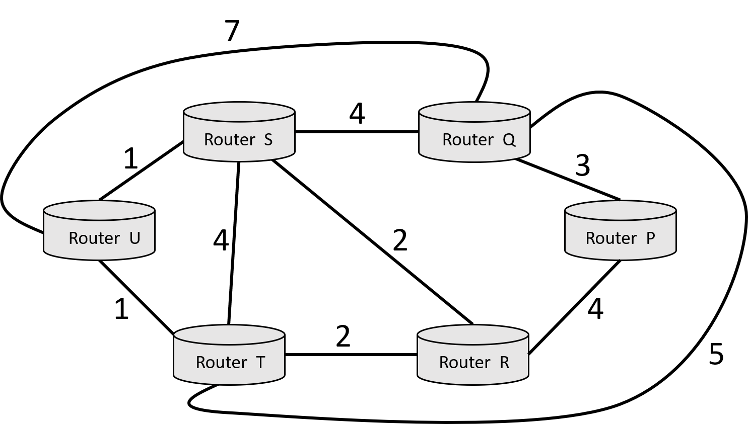

# *Figure 1. Question 9 Network*

## Question 10. (10 points)

A router has the following (CIDR) entries in its routing table:

|  |  |
| --- | --- |
| **Address/mask** | **Next hop** |
| 135.46.56.0/22 | Interface 0 |
| 135.46.60.0/22 | Interface 1 |
| 192.53.40.0/23 | Router 1 |
| default | Router 2 |

For each of the following IP addresses, what does the router do if a packet with that address arrives?

1. 135.46.63.10 **– take first 22 bits of address = 135.46.60.0, send to interface 1**
2. 135.46.57.14 **– take first 22 bits of address = 135.46.56.0, send to interface 1**
3. 135.46.52.2 **– take first 22 bits of address = 135.46.52.0, matches no rows, send to router 2 (default)**
4. 192.53.40.7 **– take first 23 bits of address = 192.53.40.0, send to router 1**
5. 192.53.56.7 **– take first 23 bits of address = 192.53.56.0, matches no rows, send to router 2 (default)**

## Question 11. (20 points)

Now, you get to be creative in designing your own secure, efficient, reliable longdistance messaging protocol. For this problem, you are to become “A Washingtonian in King Arthur’s Court” (or you can be transported to Westeros if you’re more of a *GoT* fan). Obviously, the Internet, phones and most other forms of communication do not exist. The King has commissioned you to set up a communication network to send message across the country faster than they can be carried by a group of humans manning relay stations. What solution would you propose?

Think about the protocols that we’ve studied during this quarter. Can you or do you need to implement some of these? How would that be done and how does that affect your system? Is there a restriction on the size or types of messages within your protocol? Are there other restrictions in your method (weather, health, distance of messages, etc.) that need to be addressed? Can you acknowledge messages? Do you need to? What about breakdowns in the communication medium/method you intend to use? Is there a way to add security to your messaging network? Cost? Other concerns?

Write a short spec proposal to the king laying out your ideas and how they would be implemented, what limits there are, and how you would identify and handle them plus the potential for breakdowns in the network. Use your creativity and imagination.

**The messaging system I would propose would be a multi-stop relay system. There would be stations set up very frequently across the country, where people would be hired to be part of the relaying process. Each of these stations would have a map of the stations closest to them that would most efficiently get a message to each of the eight primary cardinal directions (N, NW, W, SW, etc). When a message needs to be sent, it would be taken to the closest of these stations, addressed with its destination. Someone hired at this station, knowing the general direction it would need to go, takes it to the next corresponding station according to the station map they have. Once they get it to that station safely, they come back and notify the original sender that their message was received successfully by the next station. At each station from then on out, the sender would let the previous station know that the next segment of the message’s journey was successful, to allow for each step in the process to know the progress and location of the message during its travel. If the message is lost for whatever reason, the two applicable stations (sender and receiver) can personally work out recovering the message if possible or send information back to the original sender about the situation if not.**

**A couple big obstacles are weather and distance between these stations. If stations are kept with minimal upkeep necessary, stations can be places almost everywhere to make sure that the journey between two is as short as possible, while keeping it practical. This way there is less chance for loss of the message, obstacles in the sender’s journey, etc. Weather, on the other hand, will inevitably cause delays in the message’s journey. However, the message could be sent along a longer path in another direction rather than waiting it out to avoid more unpredictable delays. The more frequent stations will also help as the message will be getting to checkpoints much more frequently, which reduces the chance of these weather conditions causing the message to be lost at all and reducing any loss in progress along the way.**

## EXTRA CREDIT. (up to 10 points)

What are the bit values for the letters (**A** through **I**) if the below binary message is for an Extended (255, 247) Hamming Code with even parity?

**A B C** 1 **D** 1 0 1 **E** 1 1 0 1 1 1 1

1. 1 0 0 0 0 1 1 0 0 0 0 0 0 0 1
2. 1 0 0 0 0 0 0 1 0 0 1 0 1 0 1

0 0 0 1 0 0 0 1 1 1 1 0 1 1 0 1

**H** 0 1 0 1 1 0 0 1 0 1 0 0 0 0 0

1. 0 0 0 0 0 0 1 0 1 1 0 1 1 1 1
2. 0 0 0 0 1 0 1 0 0 0 1 0 1 0 1

1 0 0 0 0 0 0 1 0 0 0 0 1 1 0 1 **I** 1 1 0 0 0 1 0 1 1 1 1 1 0 0 0

0 0 0 0 1 1 1 0 1 1 1 1 0 0 0 1

1. 1 1 0 1 1 1 1 1 1 1 1 0 1 1 0
2. 1 1 0 0 1 0 1 1 0 0 0 1 0 0 1

1 0 0 0 1 0 1 1 1 1 0 0 0 1 0 0

0 0 0 0 0 1 0 0 1 0 1 0 1 0 0 1 1 1 1 1 1 1 0 0 0 0 0 1 1 0 1 1

1. 1 1 0 0 1 0 0 1 1 1 0 1 1 0 0

**(again, converting final to docx messed up the formatting, used the original PDF for reference)**

**B – column: 6 1’s, parity bit 1, B = 1**

**C – column: 5 1’s, parity bit 1, C = 0**

**D – column: 5 1’s, parity bit 0, D = 1**

**E – column: 9 1’s, parity bit 1, E = 0**

**A – row: 10 1’s, parity bit 1, A = 1**

**F – row: 3 1’s, parity bit 1, F = 0**

**G – row: 4 1’s, parity bit 1, G = 1**

**H – row: 5 1’s, parity bit 0, H = 1**

**I – row: 8 1’s, parity bit 0, I = 0**

**Verify column index 0: 8 1’s, parity bit 0, checks out**

SUPPLEMENTAL SHEET for Question 4

4a. 0 0 0 0 1 0 0 0 **0** 4b. 0 1 0 0 0 0 0 1 **0** 1 0 1 0 1 0 1 1 **1** 1 0 0 0 1 1 0 0 **1**

0 1 0 0 1 1 0 1 **0** 0 1 0 1 1 0 1 0 **0** 1 1 1 1 0 0 0 0 **0** 1 0 1 1 0 0 1 1 **1**

* 1. 0 0 0 1 1 1 0 **1** 0 0 1 1 1 0 1 0 **1**
  2. 1 0 0 0 0 1 1 **0** 1 0 0 0 0 0 0 1 **0** 0 1 0 1 0 0 1 1 **0** 1 1 1 1 1 0 0 1 **0**

1. 0 0 0 0 1 1 0 **1** 0 1 1 1 1 1 1 0 **0**

## 0 0 0 0 1 1 1 0 0 0 0 0 1 1 0 0 0 0

4c. 0 1 1 1 1 1 1 1 **1** 4d. 0 0 1 0 0 0 1 0 **0** 0 0 1 1 1 1 0 1 **0** 0 0 1 1 0 1 0 1 **0**

0 0 0 0 0 1 0 0 **1** 0 0 1 1 1 1 0 1 **1** 1 1 1 0 1 0 0 1 **1** 0 1 0 1 0 0 1 1 **0**

0 0 0 1 1 0 0 0 **0** 0 1 0 1 1 1 1 0 **1**

1. 0 1 0 0 1 1 1 **1** 0 1 1 0 1 1 1 0 **0** 0 0 1 1 1 0 0 1 **0** 0 0 1 1 0 1 0 0 **1**
2. 0 1 1 0 0 1 0 **0**  1 0 0 0 0 1 0 0 **0**

## 0 0 0 1 1 0 0 1 1 1 1 0 1 1 0 0 1 0

4e. 0 0 1 0 0 1 1 1 **0** 0 1 1 0 0 1 0 1 **0**

1. 0 0 1 1 1 1 1 **1** 1 1 1 1 1 0 0 1 **0**
2. 1 0 1 1 0 0 1 **1**

0 1 1 0 1 1 1 0 **1** 1 1 0 0 0 0 1 1 **0**

0 1 1 0 1 0 0 0 **1**

## 1 0 1 1 1 0 0 0 0